**1. Landing Page**

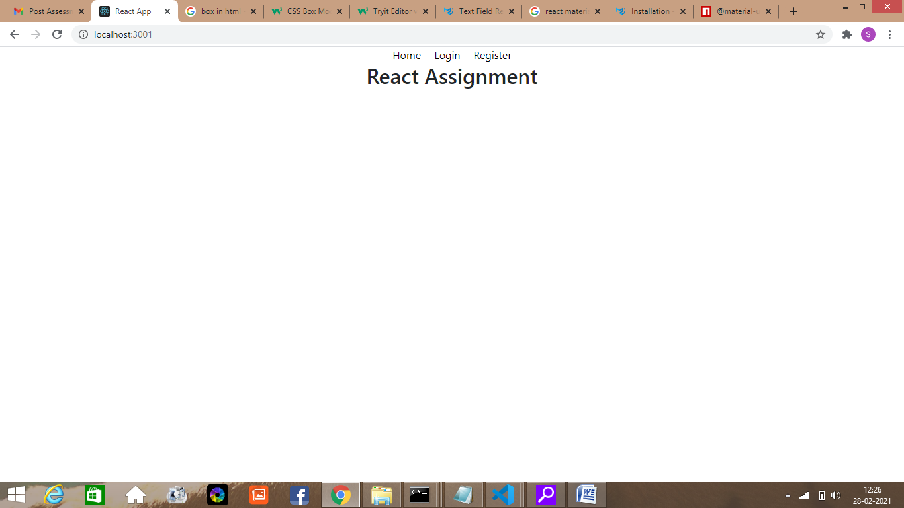

**2. Home before logged in**

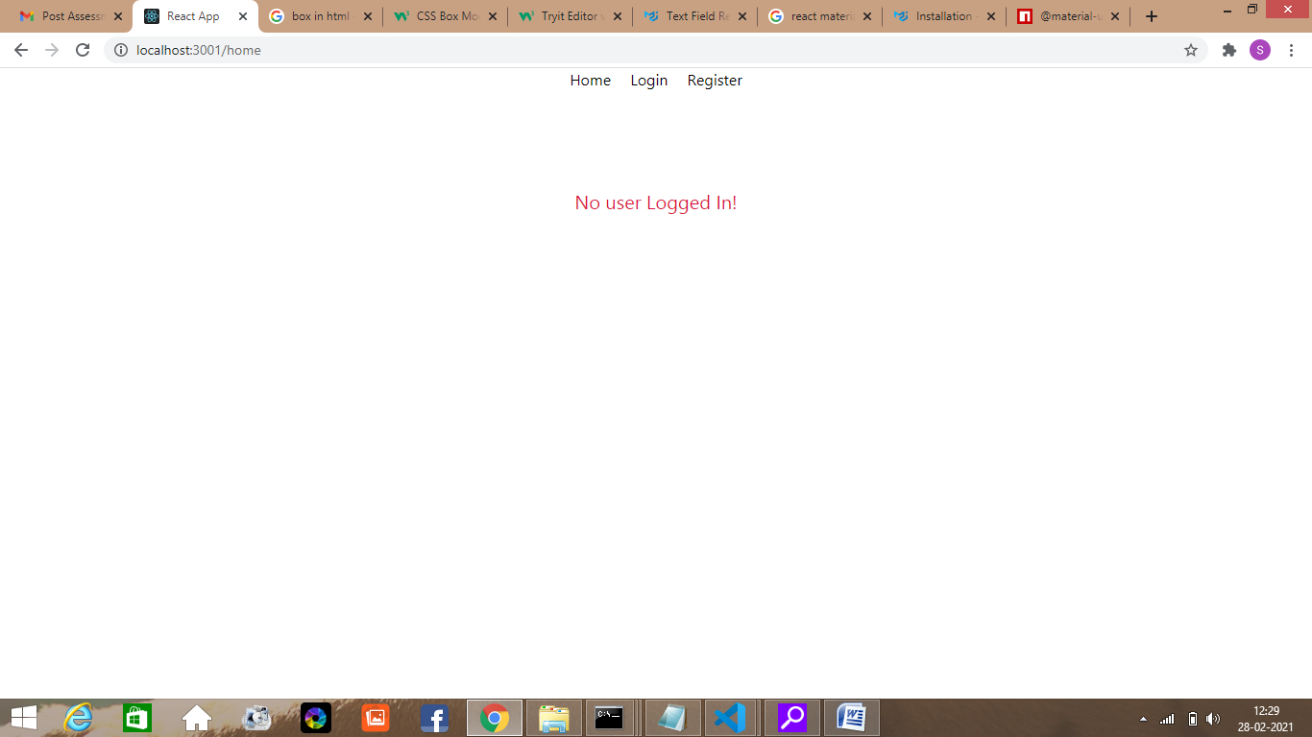

**3. Login**

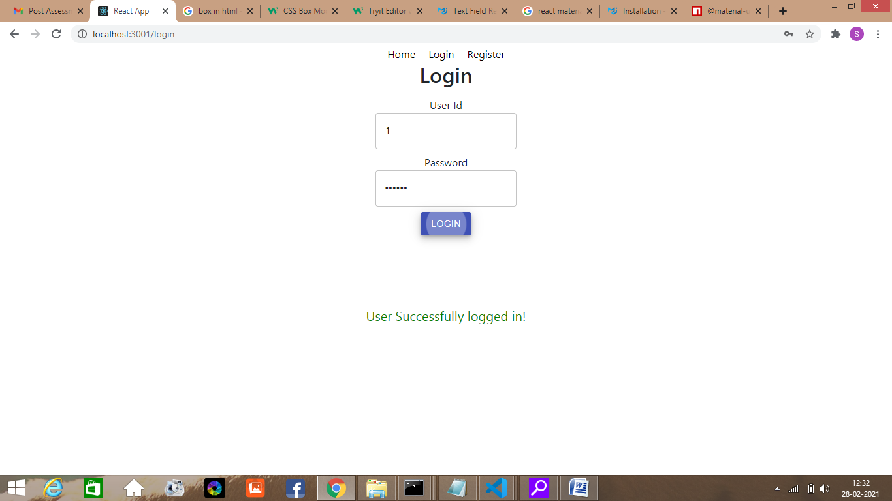

**4.Register**

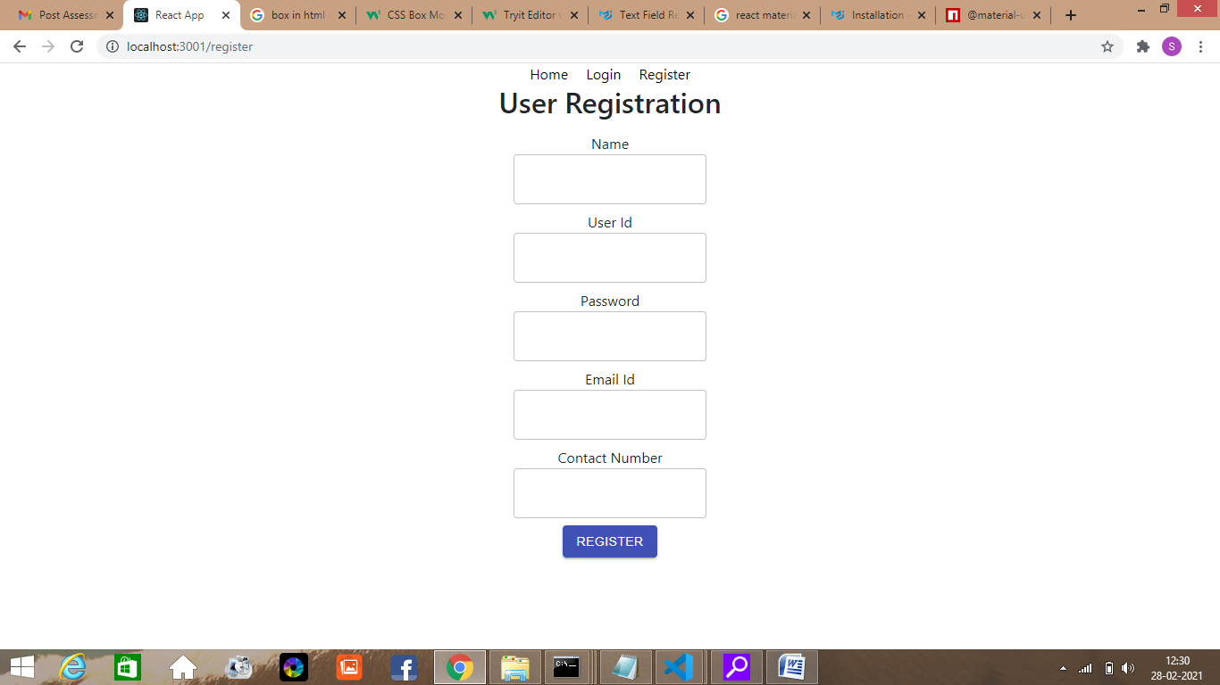

**5. Home after logged in**

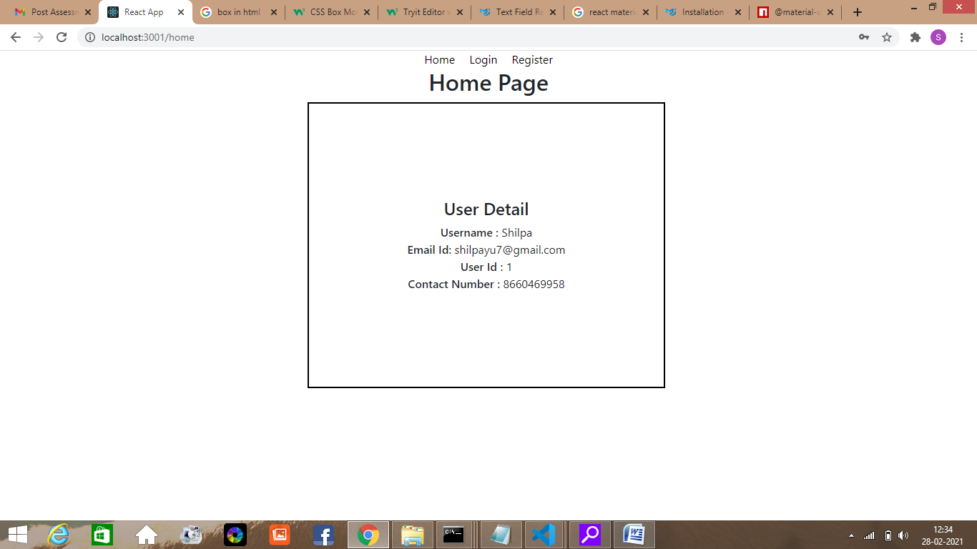

**6. Registered Data stored in db.json**

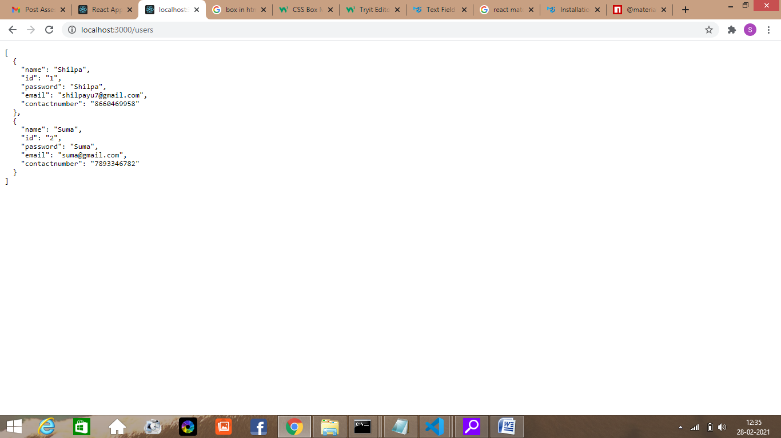

**7. After logged in User Data Stored in Redux**

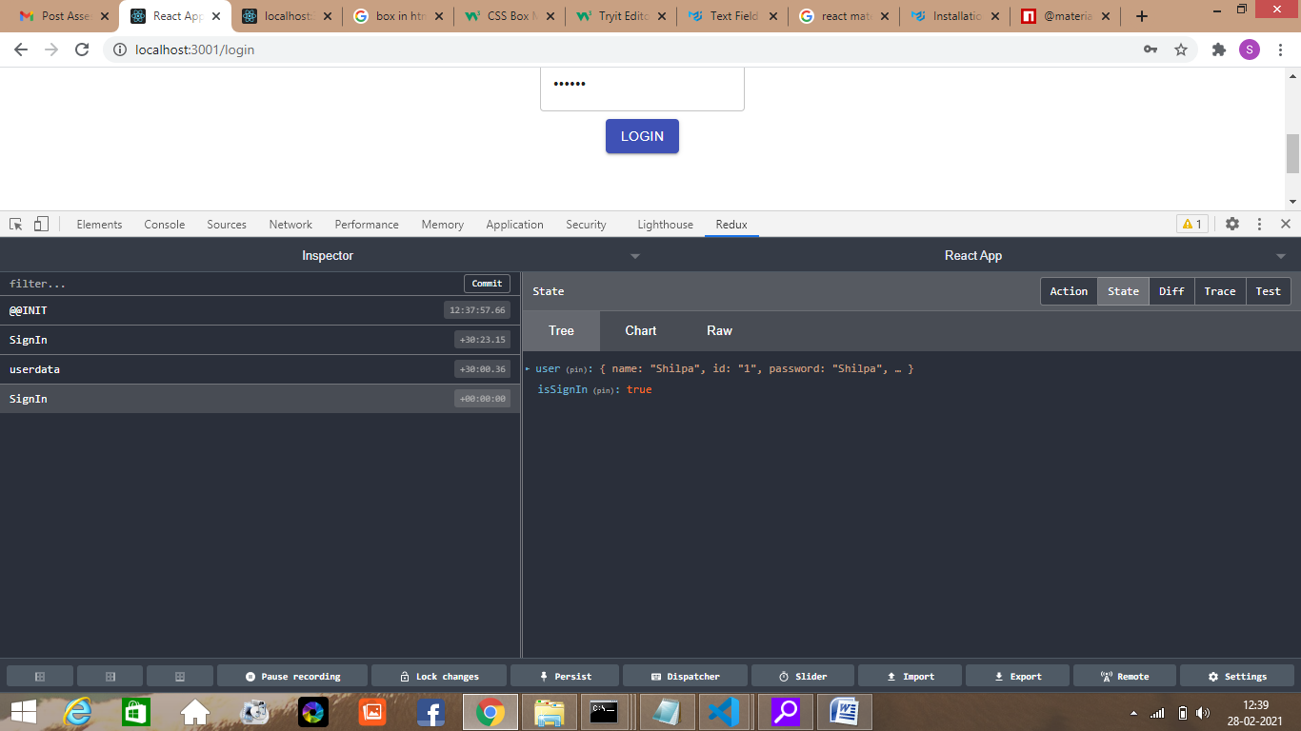

**Code Structure**

**Routing**

App.js

import './App.css';

import {BrowserRouter} from 'react-router-dom';

import RouteHandler from './RouteHandler';

import "bootstrap/dist/css/bootstrap.min.css";

function App() {

  return (

    <div className="App">

      <BrowserRouter>

         <RouteHandler/>

      </BrowserRouter>

    </div>

  );

}

export default App;

RouteHandler.js

import React from 'react';

import {Route,Switch} from 'react-router-dom';

import Nav from './Nav/Nav';

import Login from './Login/Login';

import Register from './Register/Register';

import Home from './Home/Home';

import Index from './Index/Index';

function RouteHandler(){

  return (

      <div>

          <div>

            <Nav/>

         </div>

         <div>

             <Switch>

                <Route path="/" exact component={Index}/>

                <Route path="/home" component={Home}/>

                <Route path="/login" component={Login}/>

                <Route path="/register" component={Register}/>

             </Switch>

         </div>

     </div>

  );

}

export default RouteHandler;

Nav Component Nav.js

import React from 'react';

import { NavLink } from 'react-router-dom';

function Nav() {

    const navStyle = {

      color:'black',

      padding:'10px'

    }

    return (

        <div className="nav-links">

            <NavLink style={navStyle} to="/home">Home</NavLink>

            <NavLink style={navStyle} to="/login">Login</NavLink>

            <NavLink style={navStyle} to="/register">Register</NavLink>

        </div>

    );

}

export default Nav;

Register.js

import React,{useState} from 'react';

import axios from 'axios';

import Button from '@material-ui/core/Button';

import TextField from '@material-ui/core/TextField';

import { makeStyles } from '@material-ui/core/styles';

const useStyles = makeStyles((theme) => ({

    root: {

      '& > *': {

        margin: theme.spacing(1),

        width: '25ch',

      },

    },

  }));

function Register(){

    let [name,setName] = useState('');

    let [userid,setUserId] = useState('');

    let [password,setPassword] = useState('');

    let [email, setEmail] = useState('');

    let [contactnumber,setContactNumber] = useState('');

    const url = 'http://localhost:3000/users/';

    async function RegisterUsers(e){

        e.preventDefault();

        let obj = {

            "name":name,

            "id":userid,

            "password":password,

            "email":email,

            "contactnumber":contactnumber

        }

        let results = await axios.post(url,obj);

        console.log(results);

    }

    const classes = useStyles();

    return (

        <div>

            <h2>User Registration</h2>

            <div className="align">

                <form className={classes.root} noValidate autoComplete="off">

                    <div>

                        <span>Name</span>

                        <span>

                           <TextField

                            variant="outlined"

                            id="name"

                            name="name"

                            value={name}

                            onChange={event=>setName(event.target.value)}

                            />

                        </span>

                    </div>

                    <div>

                        <span>User Id</span>

                        <span>

                           <TextField

                            variant="outlined"

                            id="userid"

                            name="userid"

                            value={userid}

                            onChange={event=>setUserId(event.target.value)}

                            />

                        </span>

                    </div>

                    <div>

                        <span>Password</span>

                        <span>

                           <TextField

                            variant="outlined"

                            type="password"

                            id="password"

                            name="password"

                            value={password}

                            onChange={event=>setPassword(event.target.value)}

                            />

                        </span>

                    </div>

                    <div>

                        <span>Email Id</span>

                        <span>

                           <TextField

                            variant="outlined"

                            type="email"

                            id="email"

                            name="email"

                            value={email}

                            onChange={event=>setEmail(event.target.value)}

                            />

                        </span>

                    </div>

                    <div>

                        <span>Contact Number</span>

                        <span>

                           <TextField

                            variant="outlined"

                            type="text"

                            id="contactnumber"

                            name="contactnumber"

                            value={contactnumber}

                            onChange={event=>setContactNumber(event.target.value)}

                            />

                        </span>

                    </div>

                    <div>

                        <Button variant="contained" color="primary" onClick={RegisterUsers}>Register</Button>

                    </div>

                </form>

            </div>

        </div>

    );

}

export default Register;

Login.js

import React,{useState} from 'react';

import axios from 'axios';

import './Login.css';

import {useDispatch} from 'react-redux';

import {signinstate,userdata} from '../action';

import Button from '@material-ui/core/Button';

import TextField from '@material-ui/core/TextField';

import { makeStyles } from '@material-ui/core/styles';

const useStyles = makeStyles((theme) => ({

    root: {

      '& > *': {

        margin: theme.spacing(1),

        width: '25ch',

      },

    },

  }));

function Login(){

    const [userid,setUserId] = useState('');

    const [password,setPassword] = useState('');

    const [message,setMessage] = useState('');

    const dispatch = useDispatch()

    const url = 'http://localhost:3000/users/'

    async function LoginUser(e){

        e.preventDefault();

        if(userid !== '' && password !== ''){

            axios.get(url+userid).then(response => {

                console.log(response);

                if(response.status === 200 && password === response.data.password){

                   dispatch(userdata(response.data));

                   dispatch(signinstate(true));

                   setMessage('User Successfully logged in!')

                }

                else {

                   dispatch(signinstate(false));

                   setMessage('Invalid Credentials!')

                }

             }, () => {

                   dispatch(signinstate(false));

                   setMessage('Invalid Credentials!')

                 }

             );

        }

        {

            dispatch(signinstate(false));

            setMessage('Please fill all the fields!')

        }

    }

    const classes = useStyles();

    return (

        <div>

            <h2>Login</h2>

            <div className="align">

                <form className={classes.root} noValidate autoComplete="off">

                    <div>

                        <span>User Id </span>

                        <span>

                        <TextField

                            variant="outlined"

                            type="text"

                            id="userid"

                            name="userid"

                            value={userid}

                            onChange={event=>setUserId(event.target.value)}

                            />

                        </span>

                    </div>

                    <div>

                        <span>Password </span>

                        <span>

                        <TextField

                            variant="outlined"

                            type="password"

                            id="password"

                            name="password"

                            value={password}

                            onChange={event=>setPassword(event.target.value)}

                        />

                        </span>

                    </div>

                    <div>

                       <Button variant="contained" color="primary" onClick={LoginUser}>Login</Button>

                    </div>

                </form>

            </div>

            <div className={message === 'User Successfully logged in!' ? 'successMsg' : 'errorMsg'}>{message}</div>

            </div>

    );

}

export default Login;

Login.css

.errorMsg{

    color:crimson;

    text-align: center;

    font-size: 20px;

    margin-top: 100px;

}

.successMsg{

    color:green;

    text-align: center;

    font-size: 20px;

    margin-top: 100px;

}

.align{

    display: flex;

    flex-direction: column;

    align-items: center;

    justify-content: center;

}

Home.js

import React from 'react';

import {useSelector} from 'react-redux';

import './Home.css';

function Home(){

    const user = useSelector(state => state.user);

    const signIn = useSelector(state => state.isSignIn);

    return (

        <div>

            {!signIn && <div className="errorMsg">No user Logged In!</div>}

            {signIn &&

               <div>

                  <h2>Home Page</h2>

                  <div className="box">

                      <h4>User Detail</h4>

                      <div>

                          <span className="bold">Username : </span>

                          <span>{user.name}</span>

                      </div>

                      <div>

                          <span className="bold">Email Id: </span>

                          <span>{user.email}</span>

                      </div>

                      <div>

                          <span className="bold">User Id : </span>

                          <span>{user.id}</span>

                      </div>

                      <div>

                          <span className="bold">Contact Number : </span>

                          <span>{user.contactnumber}</span>

                      </div>

                  </div>

               </div>

            }

        </div>

    );

}

export default Home;

Home.css

.box{

  background-color: white;

  width: 500px;

  height: 400px;

  border: 2px solid black;

  padding: 50px;

  margin: 10px;

  display: flex;

  flex-direction: column;

  align-items: center;

  justify-content: center;

  margin-left: 430px;

}

.errorMsg{

    color:crimson;

    text-align: center;

    font-size: 20px;

    margin-top: 100px;

}

.bold{

    font-weight: 600;

}

**Redux Create Store**

Index.js

import React from 'react';

import ReactDOM from 'react-dom';

import './index.css';

import App from './App';

import reportWebVitals from './reportWebVitals';

import { createStore } from 'redux';

import {Provider} from 'react-redux';

import allReducers from './reducers/index';

const store = createStore(allReducers,window.__REDUX_DEVTOOLS_EXTENSION__ && window.__REDUX_DEVTOOLS_EXTENSION__());

ReactDOM.render(

  <React.StrictMode>

    <Provider store={store}>

        <App />

    </Provider>

  </React.StrictMode>,

  document.getElementById('root')

);

reportWebVitals();

actions Index.js

export const userdata = (user) =>{

    return {

        type:"userdata",

        data:user

    }

}

export const signinstate = (value) =>{

    return {

        type:"SignIn",

        data:value

    }

}

**Combined Reducers**

Index.js

import {combineReducers} from 'redux';

import userReducer from './user';

import loggedReducer from './isloggedin';

const allReducers = combineReducers({

    user:userReducer,

    isSignIn:loggedReducer

})

export default allReducers;

**userReducer**

user.js

const userReducer = (state = 0, action) => {

    switch (action.type) {

        case 'userdata':

            return action.data;

        default:

           return state;

    }

}

export default userReducer;

**loggedReducer**

isloggedin.js

const loggedReducer = (state = false,action) => {

    switch (action.type) {

        case 'SignIn':

            return action.data;

        default:

            return state;

    }

}

export default loggedReducer;